VIETNAM NATIONAL UNIVERSITY,

HCMC UNIVERSITY OF TECHNOLOGY

FACULTY OF COMPUTER SCIENCE AND ENGINEERING



**SOFTWARE ENGINEERING (CO3001)**

**URBAN WASTE COLLECTION AID**

**UWC 2.0**

*Task 4****: Implementation***

|  |  |
| --- | --- |
| **Professors** | |
| Bùi Hoài Thắng & Nguyễn Đức Anh | |
|  | |
| **Members** | |
| Trần Phạm Minh Đăng | 2052070 |
| Ngô Trương Trọng Nghĩa | 2053264 |
| Đinh Xuân Quang | 2053359 |
| Nguyễn Hoàng Thuận | 2052729 |
| Nguyễn Trấn Quốc | 2053384 |

*Ho Chi Minh city, April 2023*

**4.1 Setting up an online repository (github, bitbucket, etc) for version control.**

In order to aid in the development of UWC 2.0, our team has created a github repository that contains the finished design and architectural files as well as future code implementation of UWC 2.0. This is the link to the Github repository:

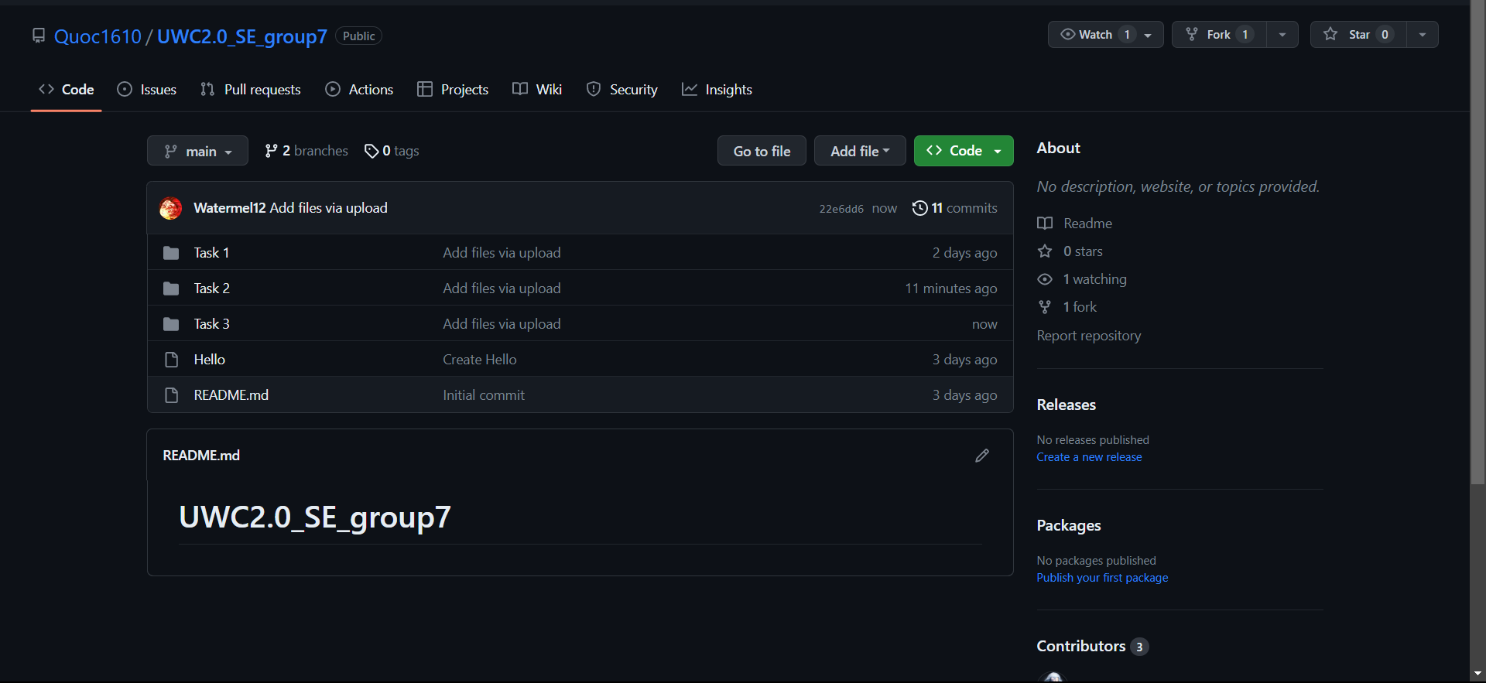**Link:** [**Repository**](https://github.com/Quoc1610/UWC2.0_SE_group7)

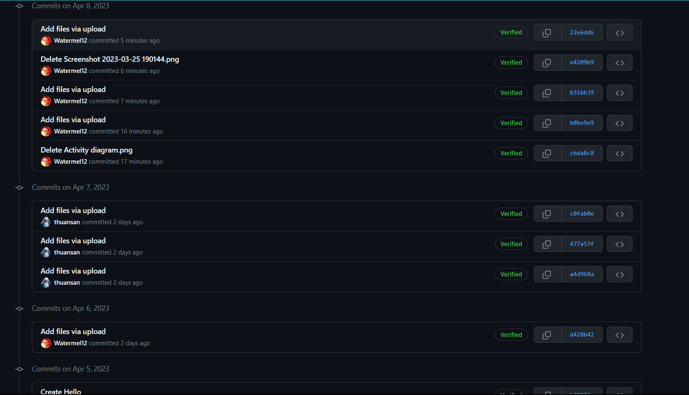**4.2 Adding documents, materials and folders for Requirement, System modelling and Architectural design. Use the selected version control system to report the changes to these files.**

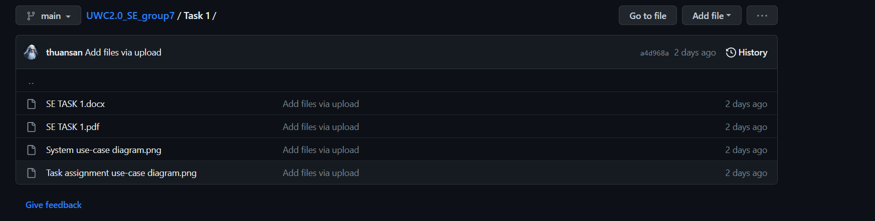**Task 1** folder includes the System use-case diagram and Task assignment use-case diagrams with the task 1’s overall report in docx and pdf.

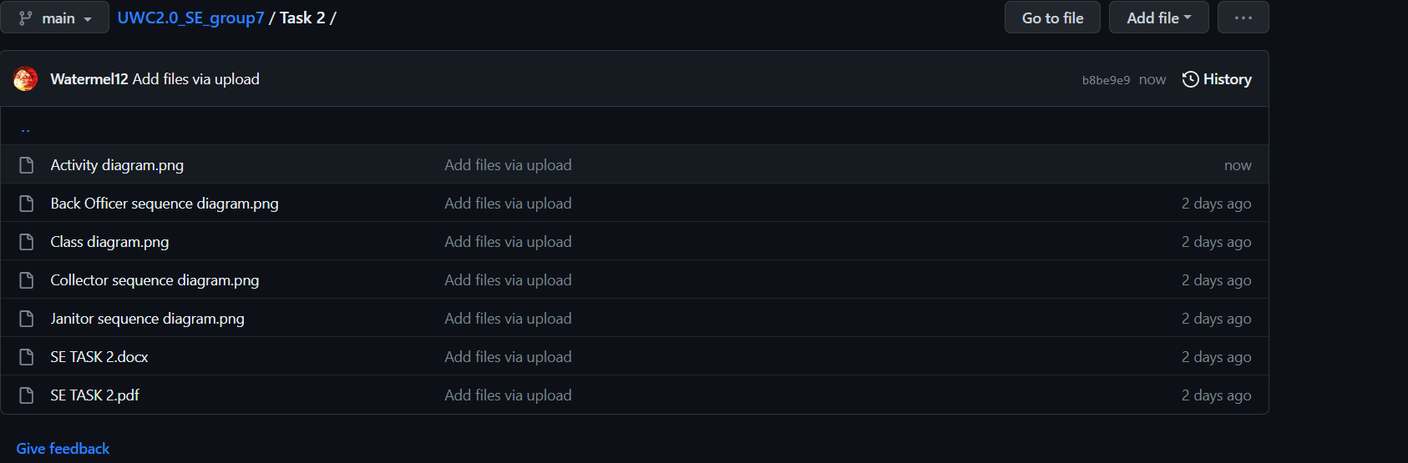**Task 2** folder comprises of Activity diagram to capture the business process between systems and the stakeholders in Task Assignment module, Class diagram of the Task Assignment module, Sequence diagrams of task assignment for janitors, collector as well as Back Officer and the overall report of the task. Design MVP1 as user interfaces for Janitors and Collectors by Figma.

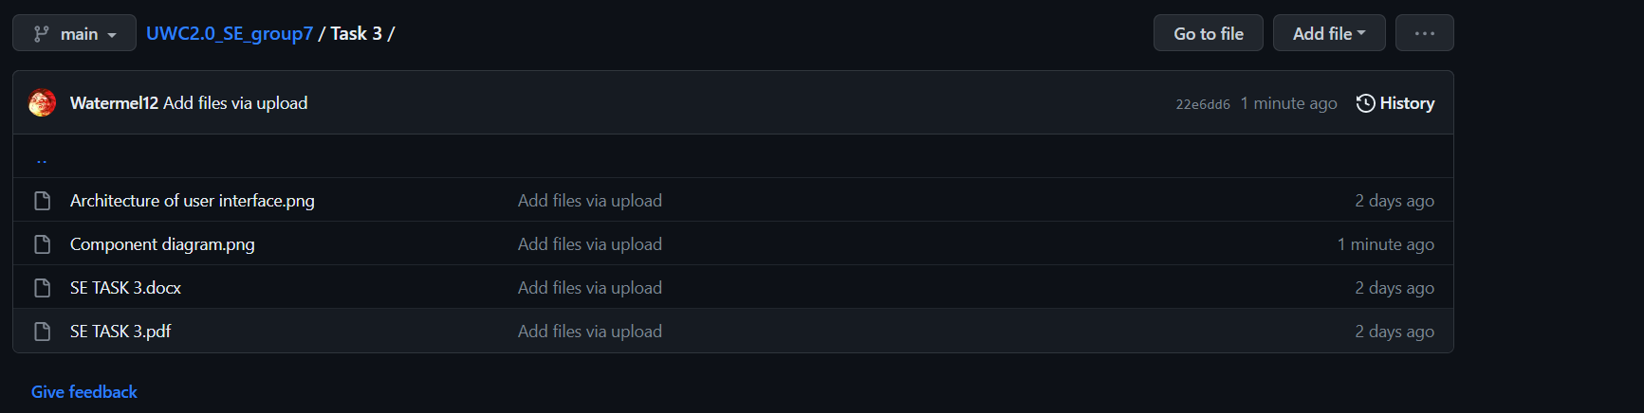**Task 3** folder encloses the following files: a layered Architecture of user interface, a Component diagram for the Task Assignment module and overall report.

**4.3 Conducted a usability test with the user interface you developed in MVP1.**

1. ***Recruit participants/testers:***

Our friends who are studying in HCMUT and other universities.

1. ***Define tasks***

* Test the **login** interface of the website.
* Test the **homepage** interface of the website.
* Test the **vehicle** information interface of the website.
* Test the **janitor** information interface of the website.
* Test the updating **area** janitor information of the website.
* Test the updating **MCP** janitor information of the website.
* Test the updating **trolley** janitor information of the website.
* Test the updating janitor information of the website after finishing the assigned task.
* Test the **collector** information interface of the website.
* Test the updating **MCP** collector information of the website.
* Test the updating **vehicle** collector information of the website.
* Test the updating collector information of the website after finishing the assigned task.
* Test the sending message interface of the website.
* Test the notification interface of the website.
* Test the log out interface of the website.

1. ***Define test strategy***

* Quantitative usability testing focuses on collecting feedback that describe the user's experience.
* Remote unmoderated remote usability tests
* 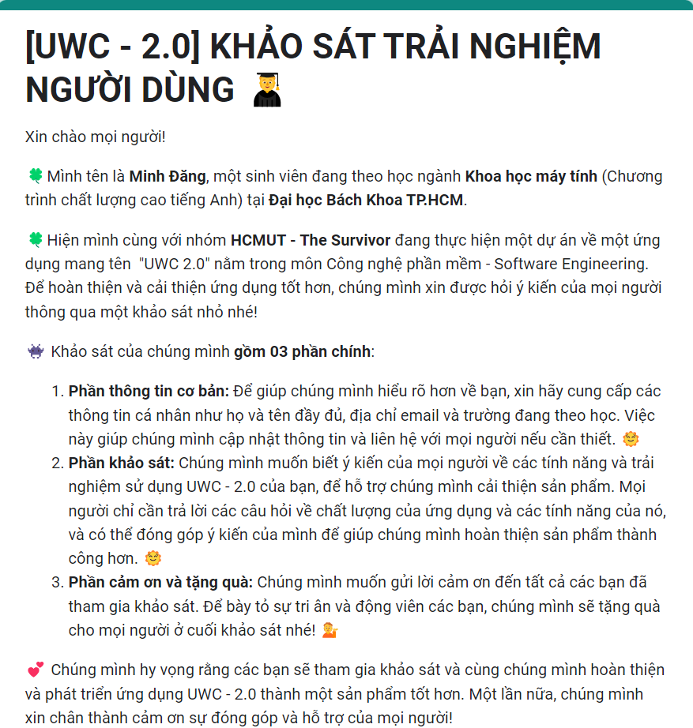We use the google form to collect the feedback . There are 3 parts in our google form : users information, survey and thank you part .

1. ***Conduct the test***

We share our link google form from 12 Am 06/04/2023 to 5Pm 08/04/2023. We have more than 20 testers that have done the google form.

Link: [Form](https://docs.google.com/forms/d/e/1FAIpQLScwnqeA5lhSockb3ARNaUbV9thgz37dlsvtYt9W3onzPCL9Kw/viewform)

1. ***Document the feedback from tester***

Link feedback data: [Feedback](https://docs.google.com/spreadsheets/d/1qWdOvAnHYPuAkXHfnWgGhQAaAruhRlwx19aywcxgPgo/edit#gid=279656322)

* Q1: Login interface
* Q2: Homepage interface
* Q3: Vehicle information
* Q4: Janitor information

The lack of color in the general design makes people feel bored, thus it is necessary to include some color that can grab their attention.

There are no instructions on the interface, which will make it difficult for users to utilize the program. Also, despite the fact that the application is made for two different user types, there is no symbol that indicates which aspect is displayed.

Biểu đồ câu trả lời của biểu mẫu. Tên câu hỏi: ✅ Cải thiện giao diện phần này (nếu có)
. Số lượng câu trả lời: 10 câu trả lời.There isn't much information in the section. It ought to display the janitor's past tasks and hours worked.

* Q5: Update area janitor information

The background of the assigning window should be blurred to make the assigned section stand out. Similar to the previous test, color is colorless and requires the addition of more information about the location in order for back offices to have more Biểu đồ câu trả lời của biểu mẫu. Tên câu hỏi: ✅ Cải thiện giao diện phần này (nếu có)
. Số lượng câu trả lời: 10 câu trả lời.selection criteria.

* Q6: Update MCP information for janitor

Biểu đồ câu trả lời của biểu mẫu. Tên câu hỏi: ✅ Cải thiện giao diện phần này (nếu có)
. Số lượng câu trả lời: 10 câu trả lời.Similar to the area assignment test, extra details are required, such as the location's photo, address, amount of trash, assigning janitors, etc.

* Q7: Update trolley janitor

The issues with the two tests mentioned above apply to Biểu đồ câu trả lời của biểu mẫu. Tên câu hỏi: ✅ Cải thiện giao diện phần này (nếu có)
. Số lượng câu trả lời: 10 câu trả lời.this test as well.

* Q8: Update janitor information after assigning task

As the general interface does not significantly alter between before and after being assigned, it is vital to draw attention to the content area in the "task for" part so that the user can recognize the differences.

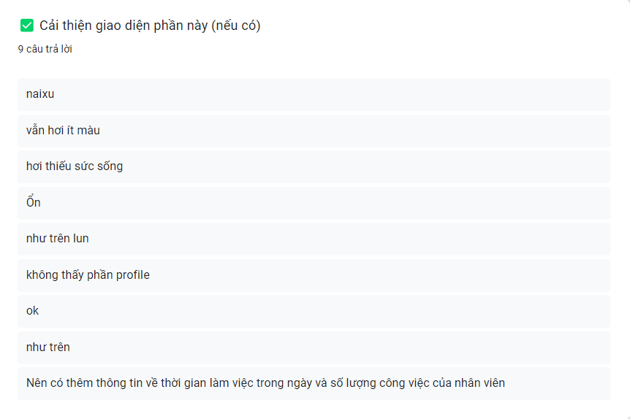

* Q9: Collector information

Most of testers want to improve the color ,information and adding profile

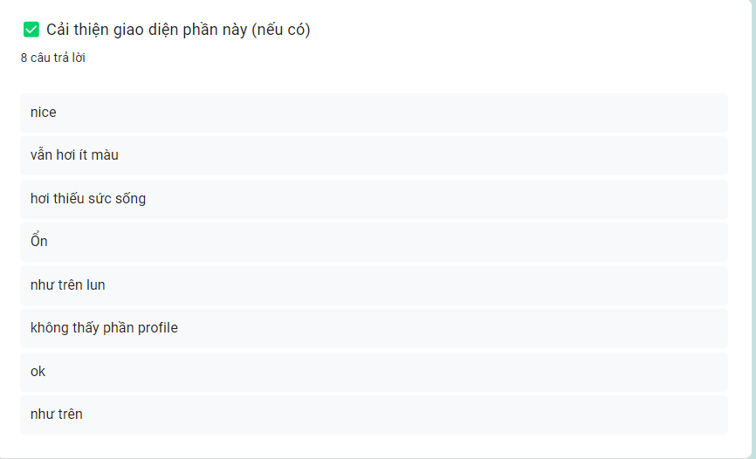

* Q10: Update MCP information for collector

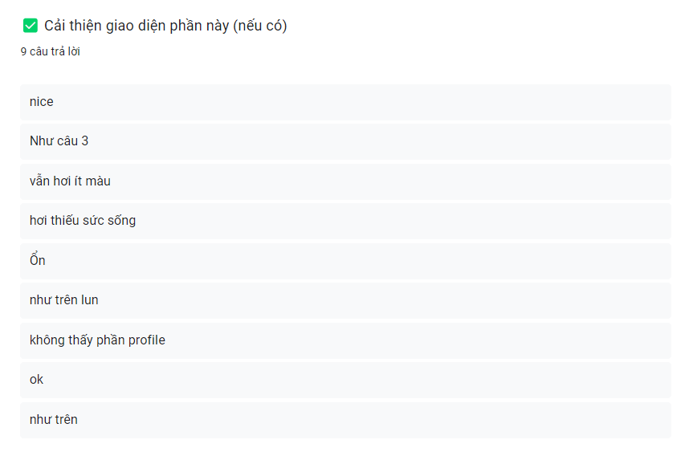Most of testers want to improve the color, information and adding profile

* Q11: Update vehicle information for collector

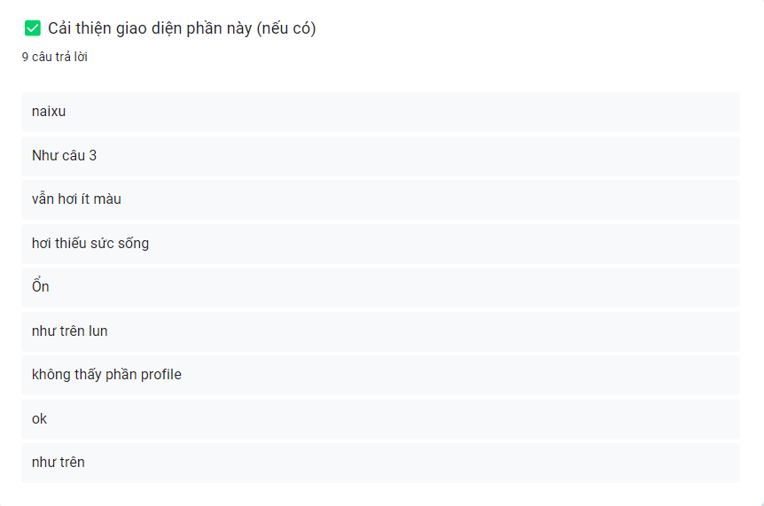Most of testers want to improve the color ,information and adding profile

* Q12: Update collector information after assigning task

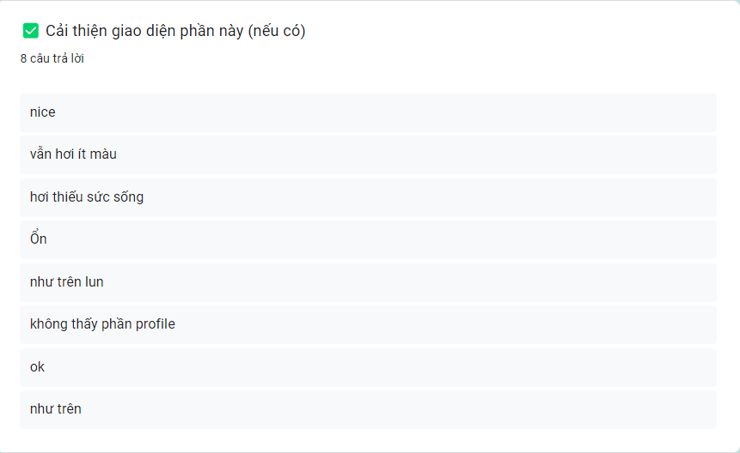Most of testers want to improve the color ,information and adding profile

* Q13: Sending message
* Q14: Notification
* Q15: Log out interface